# Kanban – Lead-Prospect-Customer

The prebuilt *Kanban – Lead-Prospect-Customer* provides an overview of registered lead, prospects and customers in your NetSuite account, with each Kanban column representing a customer stage. The first Kanban column contains entity record without an assigned sales rep.  
  
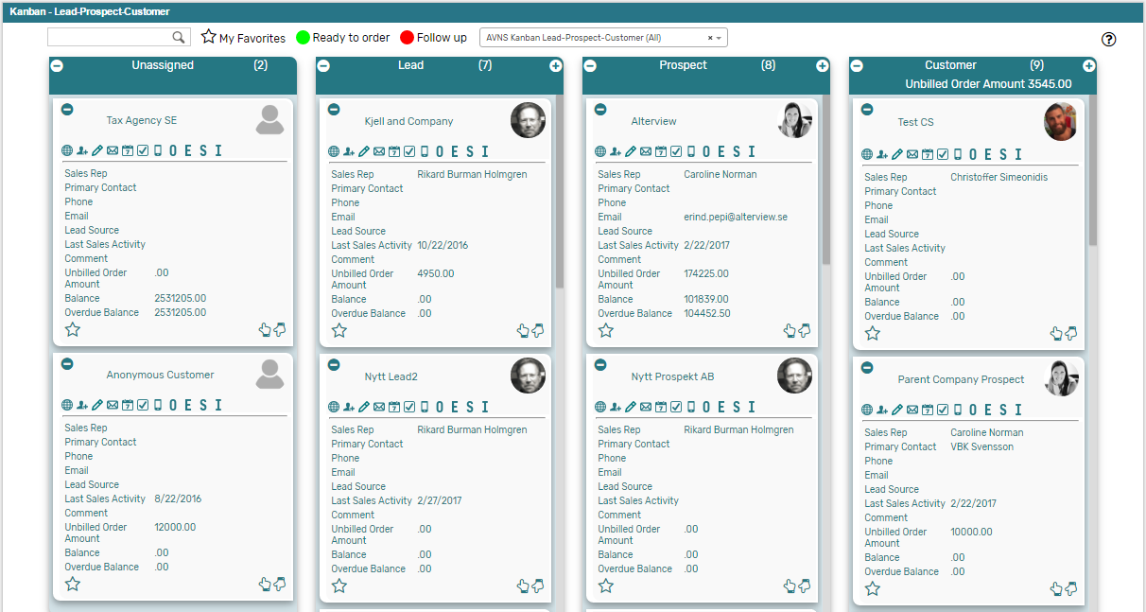

### Kanban – Lead-Prospect-Customer: Prerequisites

Before using the *Kanban – Lead-Prospect-Customer* board, please make sure the prerequisites listed below are fulfilled in order for the board to function as expected.

1. **Customer Status**  
   Moving cards between columns in the prebuilt *Kanban – Lead-Prospect-Customer* board will update the status of the record in the Kanban card to one of the NetSuite standard Customer status. Therefore, it is important that the statuses referred to in the board are available in your NetSuite account.   
     
   Navigate to Setup 🡪 Sales 🡪 Customer Statuses (Administrator) to find the list of Customer Statuses available in your NetSuite account. Compare the list from your NetSuite account with the Customer Status list which the prebuilt *Kanban – Lead-Prospect-Customer* refer to (picture below).   
     
   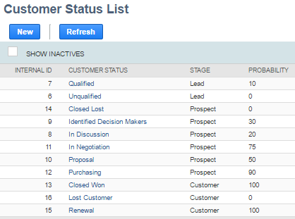  
     
   If the Customer Statuses differ between your NetSuite account and the picture above, you will need to edit the settings of the Kanban Columns for the *Kanban – Lead-Prospect-Customer* board.  
   ***Please refer to the section ‘Kanban Columns’ in the ‘Kanban User Guide’***
2. **Sales Rep & Sales Rep Image**  
   Make sure to mark the checkbox ‘Sales Rep’ on the Employee record for all available Sales Reps.   
   If an image has been uploaded to the *Image* field on the Employee record, this image will be displayed on the Kanban card. If no image is available, a predefined profile icon will be displayed instead.
3. **Report 360**The *Kanban – Lead-Prospect-Customer* board includes the *Customer 360* PDF-report, built with Alterview native SuiteApp Report 360. To enable the *Customer 360* report, the SuiteApp Report 360 (bundle 106006) and Report 360 Prebuilt reports (bundle 120140) are required. Make sure to install both bundles in order to display the *Customer 360* report.

### 

### Kanban – Lead-Prospect-Customer: Card Moves & Column Actions

The *Kanban – Lead-Prospect-Customer* board contains four Kanban Columns. Each column has been configured with one or several Column Actions. Double clicking on any card in the *Kanban – Lead-Prospect-Customer* board will open the entity record in edit mode.

1. **Unassigned**
   1. *Card Moves* – Kanban cards in the column *Unassigned* can be moved to all other columns in the Kanban board.
   2. *Column Actions* – when moving a Kanban card to the column *Unassigned* the Sales Rep field will be emptied and the entity will become unassigned.
2. **Lead**
   1. *Card Moves* – Kanban cards in the column *Lead* can be moved to all other columns in the Kanban board.
   2. *Column Actions* – when moving a Kanban card to the column *Lead* the status of the record represented in the Kanban card will be updated to *LEAD* – *Qualified* and the Sales Rep will be set to *@MySELF@* (Current User).
   3. *Add Card* – it is possible to add a Kanban card (a new record) from the column *Lead* by clicking on the + icon in the top right corner of the column.
3. **Prospect**
   1. *Card Moves* – Kanban cards in the column *Prospect* can be moved to all other columns in the Kanban board.
   2. *Column Actions* – when moving a Kanban card to the column *Prospect* the status of the record represented in the Kanban card will be updated to *PROSPECT* – *In Discussion* and the Sales Rep will be set to *@MySELF@* (Current User).
   3. *Add Card* – it is possible to add a Kanban card (a new record) from the column *Prospect* by clicking on the + icon in the top right corner of the column.
4. **Customer**
   1. *Card Moves* – Kanban cards in the column *Customer* can be moved to all other columns in the Kanban board.
   2. *Column Actions* – when moving a Kanban card to the column *Customer* the status of the record represented in the Kanban card will be updated to *CUSTOMER* – *Closed* *Won*.
   3. *Add Card* – it is possible to add a Kanban card (a new record) from the column *Customer* by clicking on the + icon in the top right corner of the column.
   4.  *Column Aggregation –* there is a column aggregation in the *Customer* column, which calculates the sum of all unbilled orders for the records in the column to display the amount in the column header section.

### Kanban – Lead-Prospect-Customer: Available Card Actions

The Kanban cards in the *Kanban – Lead-Prospect-Customer* board each contains eleven Card Actions.

1. **View Customer 360**  
   View a customer 360 report of the entity from the Kanban card.
2. 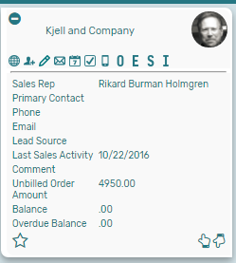**Customer: New Contact**Add a new contact to the customer from the Kanban card.
3. **Customer: New Note**Add a new note to the customer from the Kanban card.
4. **Customer: New Email**Add a new email to the customer from the Kanban card.
5. **Customer: New Event**Add a new event to the customer from the Kanban card.
6. **Customer: New Task**Add a new task to the customer from the Kanban card.
7. **Customer: New Phone Call**Add a new phone call to the customer from the Kanban card.
8. **Customer: New Opportunity**Add a new opportunity to the customer from the Kanban card.
9. **Customer: New Estimate**Add a new estimate to the customer from the Kanban card.
10. **Customer: New Sales Order**Add a new sales order to the customer from the Kanban card.
11. **Customer: New Invoice**Add a new invoce to the customer from the Kanban card.

### Kanban – Leads-Prospect-Customer Alternative Searches

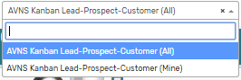There are two alternative searches for the *Kanban – Lead-Prospect-Customer* board.

1. **AVNS Kanban Lead-Prospect-Customer (All)**This search will display all registered leads in the *Kanban – Lead-Prospect-Customer* board.
2. **AVNS Kanban Lead-Prospect-Customer (Mine)**This search will display registered prospects where Sales Rep is *Mine* (current user) in the *Kanban – Lead-Prospect-Customer* board.

### Kanban – Lead-Prospect-Customer: Available Colors

There are two colors available for the *Kanban – Lead-Prospect-Customer* board, which can be used to highlight and filter the Kanban cards (*Ready to order // Follow up*). These are defined in the *Color* subtab of the Kanban configuration record.